Four River Valley Civilizations Test Study Guide Name_______key____________________
Directions: Identify each civilization and the river(s) that helped it emerge (start).

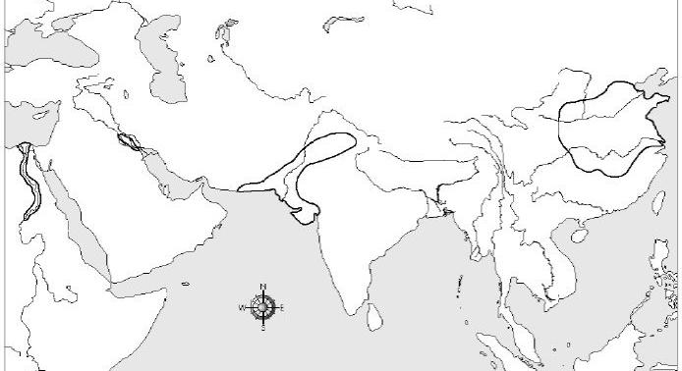
D
C
B
A

- A: Egypt, Nile River
- B: Mesopotamia, Tigris and Euphrates Rivers
- C: Indus River Valley, Indus River
- D: Huang He (Yellow River), China
Word bank for 2,3,4,5: Nile, Tigris and Euphrates, Yellow (Huang He, Indus)
5. What river civilization was nicknamed China’s sorrow? Yellow (Huang He)
6. What are the rivers were the located in the Fertile Crescent? Tigris and Euphrates
7. What civilization considered predictable flooding as a gift? Nile River
8. Monsoons made this river unpredictable. Indus River
9. What mountain range to the north of the Indus Valley civilization has the tallest mountains in the world? Himalaya
10. What geographic features dominate China’s landscape? mountains and plains

11. Mesopotamia means between the rivers.

12. The Nile River runs NORTH and empties into Mediterranean Sea.

13. Mesopotamia is known as the Fertile Crescent because it has nutrient rich soil good for farming.

14. One of Japan’s geographic disadvantages is limited natural resources.
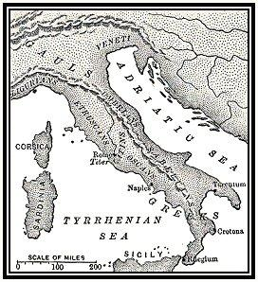
15. The map above, infers that early Ancient Rome had easy access to many different seas.
16. The above map illustrates Ancient Italy’s physical features.

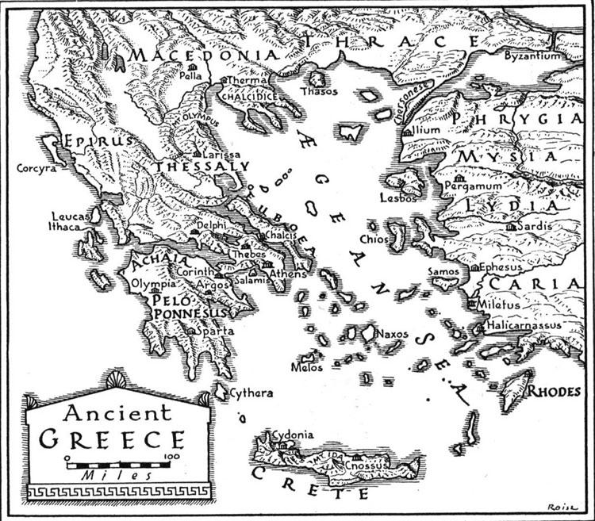

17. Based on the map above, one can infer there are many mountains.

18. According to the map above, what physical features isolate the city states of Greece?
Mountains, islands, seas

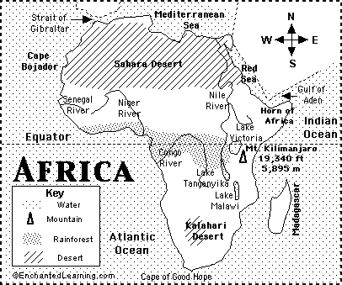
19. The map above infers Africa has geographic diversity.

20. According to the map above, the rainforest is located in central Africa.

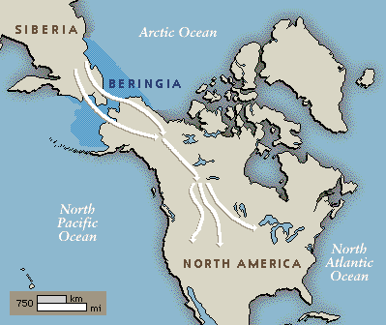
21. The arrows on the map above represent a theory about the first Americans.

22. A distinguishing cultural feature of a region, is a country with multiple national languages, because of the ethnic makeup of the nation.

23. Factors that led to the development of the civilizations of Ancient Egypt and Ancient Mesopotamia was favorable geography.
24. Civilizations controlled the flooding of rivers by moving the fields back away from the rivers, building levies and canals, and building dams on the rivers.

25. The physical characteristics of a place include its landforms and vegetation.

26. Physical features and human characteristics has had the greatest influence on the overall development of a civilization.

27. Many early civilizations settled near bodies of water because a body of water was necessary to keep the civilization thriving, and helped promote farming, transportaion and trade.

28. Architecture is a human characteristic of a place.

29. The desert was a natural barrier that helped keep Egypt free from many invasions.

30. Irrigation is bringing water to crops.

31. Reservoirs are used to store water.
32. One main problem with irrigation canals was they became clogged with silt.

33. Large, earthen walls built to control flooding are known as levees.
34. Romans built aqueducts to carry water from the mountains to the valleys for irrigation and drinking.
35. An outcome of living in a mountainous country is: mountains provide protection from enemies; mountains isolate one group of people from another; and mountains make travel difficult.
36. When humans stopped being nomads and started to permanently settle in different regions, humans invented tools, domesticated animals and learned how to farm.

37. Canals for irrigation helped influence farming in ancient Mesopotamia.

38. Irrigation systems led to increased food production in both Ancient Mesopotamia and Egypt.

39. According to the map below, it was necessary for city-states to be located near a body of water, because water was necessary for many aspects of life, including farming, irrigation and transportation.

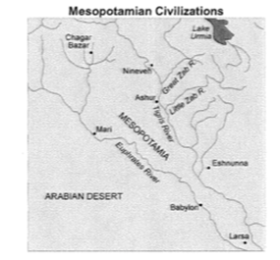
40. Ancient Mesopotamia experienced frequent invasions that caused many city-states to be conquered or completely collapse. This was due to there were no major natural barriers between Mesopotamia and other societies.

41. Silt was the rich mud left behind after a river flooded. Silt was very important to the early people of Mesopotamia because it made the land fertile for farming.

42. Mountains, hills, and deserts helped the Chinese to thrive because these features protected China from invasion.

43. One disadvantage of living on a peninsula is you are isolated from other civilizations.

