Figurative Language Personal Vocabulary Bank

Term | Definition | Mentor Example | Example from Independent Reading Novel
Alliteration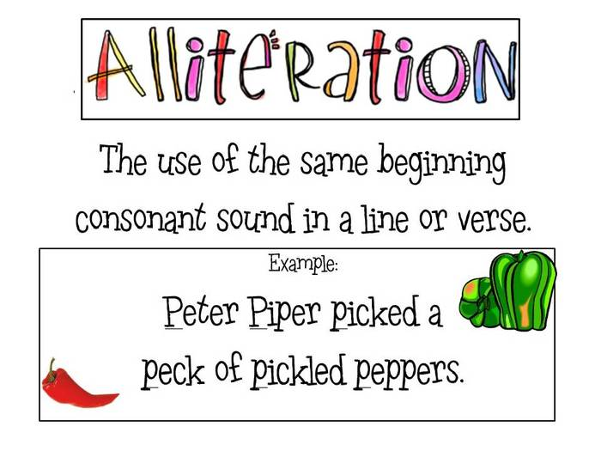 | Repetition of initial consonant sounds | “And the silken, sad, uncertain rustling of each purple curtain…”  ― Edgar Allan Poe “The Raven”  The rain ran.
Simile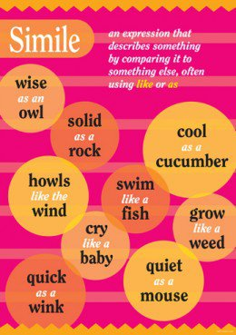 | Comparison of two things using “like” or “as” | “He'd felt like a jack-o-lantern for the past few days, as if his guts had been yanked out with a fork and dumped in a heap while a grinning smile stayed plastered on his face.”  ― Cassandra Clare, City of Ashes  “A thief is a lot like a wizard. I have quick hands. And I can make things disappear. But then I stole the magician’s locus magicalicus and almost disappeared myself forever.”  ― Sarah Prineas The Magic Thief  So I opened it-you cannot imagine how stealthily, stealthily-until, at length a single dim ray, like the thread of the spider, shot from out of the crevice and fell upon the vulture eye.  ―Edgar Allan Poe “The Tell-Tale Heart”
Metaphor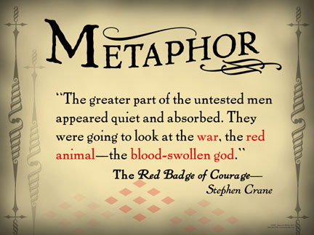 | Comparison of two things using “is” or “are” | Fame is a Bee.  ― Emily Dickinson  And each separate dying ember wrought its ghost upon the floor.  ―Edgar Allan Poe “The Raven”
Onomatopoeia  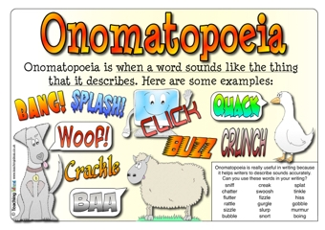 | Words that imitate a sound | And yes, there it was, slowly chugging and clanging into the station, the old steam engine and the rackety carriages finally hissing to a halt.  ― Felice Holman The Wild Children  A few minutes later we heard, Whoosh! “Ahhhhh!” Thud! “Ugh!” He was back.  ― Jack Gantos “The Follower”
Imagery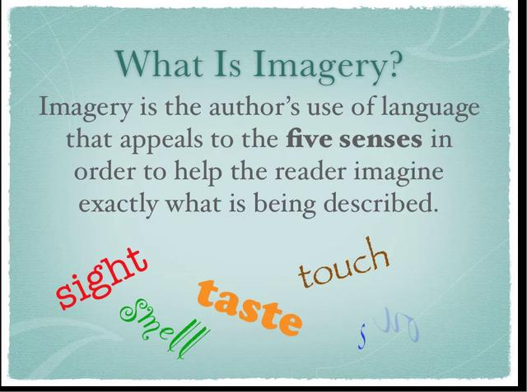 |  | “…and all that was left of the day was that fugitive red glow on the horizon”  ― Tommy Wallach We All Looked Up  “Below, my father sat across from a tall, broad shouldered man with graying hair at his temples, his hair tied back at the nape of his neck in a shirt, customary tail, the velvet of his coat shining black and orange in the light.”  ― Marie Lu The Young Elites
Hyperbole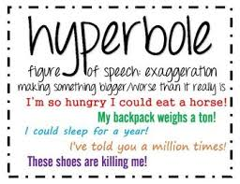 | An extreme exaggeration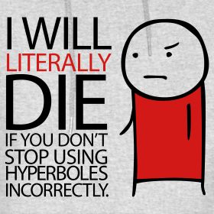 | “But Tolka was always able to make a fire out of nothing…out of snow, it seemed, if need be.”  ― Felice Holman The Wild Children
Assonance  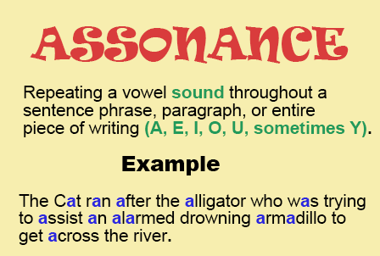 | Repetition of a vowel sound or diphthong in non-rhyming words | "The rain in Spain stays mainly on the plain."  -My Fair Lady  “And the silken, sad, uncertain rustling of each purple curtain thrilled me - filled me with fantastic terrors...”  ― Edgar Allan Poe “The Raven”
Repetition  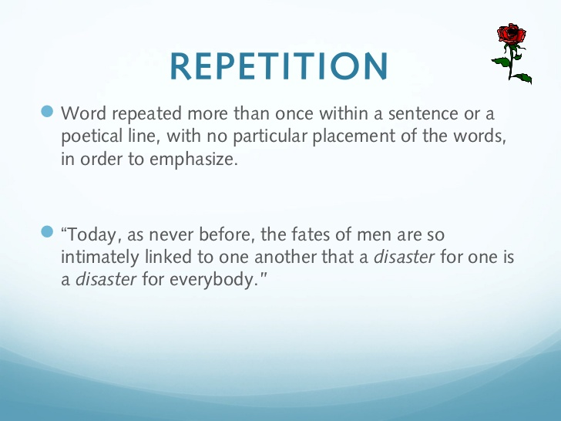 |  | “The children thought lions, and there were lions. The children thought zebras, and there were zebras. Sun - sun. Giraffes - giraffes. Death and death.  That last. He chewed tastelessly on the meat that the table bad cut for him. Death thoughts. They were awfully young, Wendy and Peter, for death thoughts. Or, no, you were never too young, really. Long before you knew what death was you were wishing it on someone else.”  ― Ray Bradbury “The Veldt”  “Rage, rage, against the dying of the light.”  ―Dylan Thomas “Do Not Go Gentle into the Good Night”
Anaphora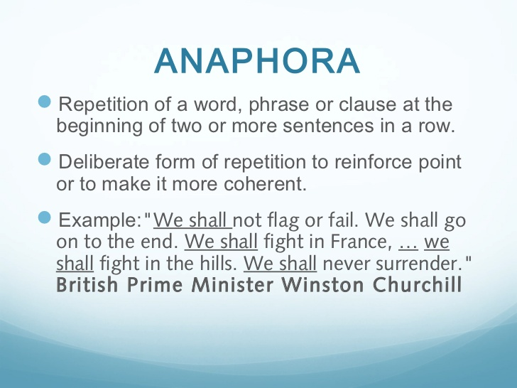 | Repetition of a word or phrase at the beginning of successful clauses | “Five years have passed;  Five summers, with the length of  Five long winters! and again I hear these waters…”  ― William Wordsworth Tintern Abbey
Personification  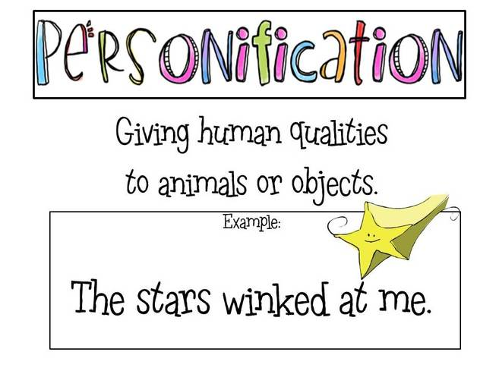 | Giving human qualities to animals or objects. | “Laura Lynn,” Ms. Elliot called, her deep throaty voice bouncing off the cinder block walls and smacking me in the face.  ― Laura Lynn “20/20”  A scent of perfume arose from it that bit into Alex’s memory for a moment and made him close his eyes.  ― Felice Holman The Wild Children
Combination:  Personification  Hyperbole  Metaphor |  | How a day can creep! Not move at all! There it sits a block of time to be cut through slowly with a dull saw.  ― Felice Holman The Wild Children

